*Florida International University*

*School of Computing and Information Sciences*

Software Engineering Focus

Feature Document

User Story #**89 - Unity Scene 2**

**Team Member:**

Jacob Leschen

**Product Owner(s)**:

Francisco Ortega

**Instructor**: Masoud Sadjadi

**User Story** Implement a new scene in unity that takes advantage of HMD features, such as object manipulation and scene transition

* As a developer, I would like a second unity scene, with more functions, and the ability to switch between scenes, so that I can emulate the user experience for the project.

Acceptance Criteria

* Objects like light sources, movable models with physics, intractable objects, movement and camera controls
* Able to view on HMD device and use HMD control scheme
* Able to switch between scenes in unity using UI

**Use Case** #**1 – Changing Scenes -** User can change between the first unity scene and the second by pressing a button

**Use Case #2 -- Object Manipulation** - Framework for a pickup function where the user can manipulate an object

**Use Case #3 -- Textures, Models, and Light Sources -** Scene has graphical resources

**Use Case #4 -- Unity Scene**

**Use Case Diagram**

Usecase4.png

**Sequence Diagram**

sequence4.png

**Class Diagram**

class4.png

**Unit Test**

Test case: Pick up object

Purpose: Test to see if object framework can pick up object and track the controller

Preconditions: user has no other objects picked up

Action: User moves controller over the object’s model, presses the pickup button, then moves the controller

Expected result: Object should start tracking the controller’s movements: velocity, rotation, trajectory when the button is released

Test case: Change scene

Purpose: Test to see if user can swap between scenes

Preconditions: User has no object picked up

Action: user presses the teleport button

Expected result: User should load the other unity scene (there are only two at this point)

**Visual User Guide**

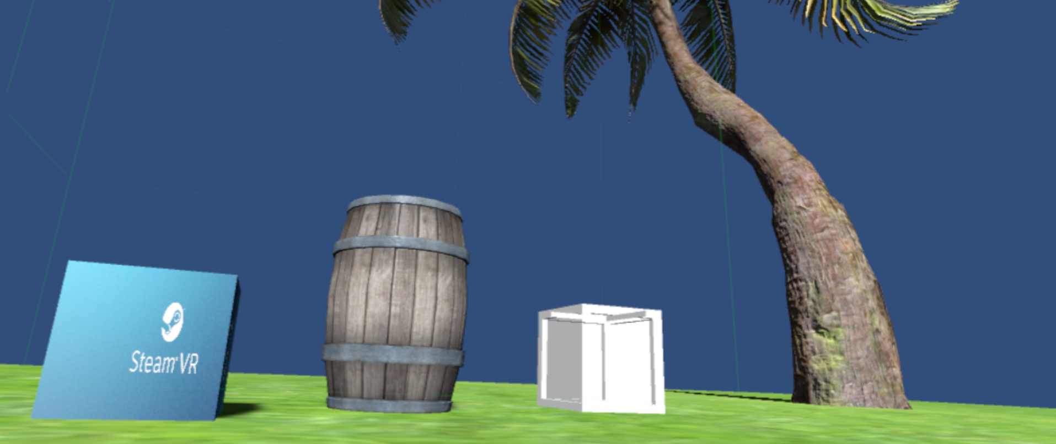  
Screenshot of scene - 3 testing objects of differing weights that can be moved with the controller, one object (tree) that cannot be moved, a directional light source, and the vr chaperone visible

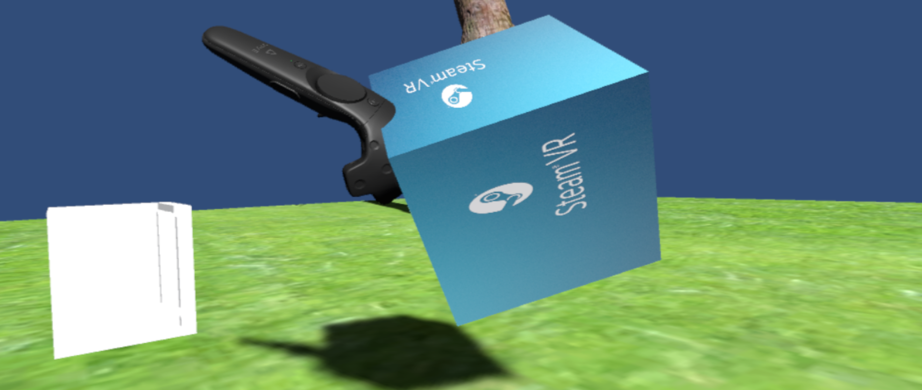

Visualization of object pickup - objects can be rotated and thrown with real physics